EXPLORATORY DATA ANALYSIS AND VISUALIZATION

Submitted by: Asiya B
Course: Diploma in Artificial Intelligence
Task: Week 2 – Exploratory Data Analysis and Visualization
Tools Used: Python, Pandas, Matplotlib, Seaborn
Dataset: Netflix Movies and TV Shows Dataset

1. INTRODUCTION
Exploratory Data Analysis (EDA) is an important step in the data analysis process. It involves examining, cleaning, summarizing, and visualizing a dataset to understand its main characteristics and identify useful patterns, trends, relationships, and unusual observations.
In this project, Exploratory Data Analysis and Visualization are performed on a public dataset containing information about movies and television shows available on Netflix.
The analysis is performed using Python and popular data analysis and visualization libraries such as Pandas, Matplotlib, and Seaborn. Different statistical methods and visualizations are used to understand the structure of the dataset and extract meaningful insights from it.
The project also demonstrates data cleaning, handling of missing values, descriptive statistics, aggregation, categorical analysis, numerical analysis, and correlation analysis.

2. OBJECTIVE
The main objectives of this project are:
- To understand the structure and characteristics of a public dataset.
- To inspect the dataset and identify its important variables.
- To detect and handle missing and duplicate values.
- To perform basic descriptive statistical analysis.
- To explore numerical and categorical variables.
- To identify trends and patterns within the dataset.
- To create meaningful visualizations using Matplotlib and Seaborn.
- To analyze relationships and correlations between suitable variables.
- To interpret the results obtained from the visualizations.
- To summarize the important findings obtained from the exploratory analysis.

3. DATASET SELECTION
For this project, the Netflix Movies and TV Shows dataset was selected as the public dataset for Exploratory Data Analysis.
The dataset contains information about movies and television shows available on Netflix. It includes variables such as title, type, director, cast, country, date added, release year, rating, duration, listed-in categories, and description.
This dataset was selected because it contains a combination of categorical, numerical, and date-related variables. Therefore, it provides suitable opportunities to demonstrate different exploratory data analysis and visualization techniques.
The dataset can be used to investigate questions such as:
- What is the distribution of movies and TV shows?
- Which years had the highest number of releases?
- Which ratings are most common?
- Which countries contribute the most content?
- What are the most common content categories?
- How has Netflix content changed over time?
- What is the relationship between release year and other variables?
- Are there any unusual or missing values in the dataset?

4. DATASET DESCRIPTION

The major columns in the dataset are described below:

Column | Description
show_id | Unique identification number assigned to each title
type | Indicates whether the title is a Movie or TV Show
title | Name of the movie or TV show
director | Director of the title
cast | Main cast members
country | Country or countries associated with the title
date_added | Date on which the title was added to Netflix
release_year | Original release year of the title
rating | Content rating
duration | Duration of a movie or number of seasons of a TV show
listed_in | Categories or genres associated with the title
These variables allow both individual and combined analysis of Netflix content.

5. TOOLS AND LIBRARIES USED
The following tools and Python libraries were used in this project:
Python
Python was used as the main programming language for data analysis.
Pandas
Pandas was used for:
- Loading the dataset
- Inspecting the data
- Cleaning the dataset
- Handling missing values
- Removing duplicates
- Performing grouping and aggregation
- Calculating descriptive statistics
NumPy
NumPy was used for numerical operations where required during the analysis.
Matplotlib
Matplotlib was used to create visualizations such as:
- Bar charts
- Histograms
- Line charts
- Scatter plots
- Other customized plots
Seaborn
Seaborn was used to create statistical visualizations such as:
- Count plots
- Box plots
- Heatmaps
- Distribution plots

6. LOADING THE DATASET
The dataset was loaded into Python using the Pandas library.
The CSV file was read using the read_csv() function and stored in a Pandas DataFrame.
The following code was used:
import pandas as pd
import numpy as np
import matplotlib.pyplot as plt
import seaborn as sns

df = pd.read_csv("netflix_titles.csv")

df.head()
The head() function was used to display the first five rows of the dataset and understand how the data is organized.
Interpretation
The first few rows provide an initial understanding of the variables and the type of information stored in each column.

7. INITIAL DATA INSPECTION
After loading the dataset, an initial inspection was performed to understand its size, structure, data types, and contents.
7.1 Checking Dataset Shape
The shape of the DataFrame was checked using:
df.shape
The output represents the number of rows and columns in the dataset.
Interpretation
The dataset contains multiple records representing Netflix titles, with several attributes describing each title.

7.2 Checking Column Names
The column names were examined using:
df.columns
The dataset contains variables related to title information, classification, release details, country, duration, and categories.

7.3 Checking Data Types and Structure
The info() function was used to examine the data types and identify columns containing missing values.
df.info()

Interpretation
The output helps identify which columns contain numerical data, categorical data, and date-related information. It also provides an initial indication of missing values in different columns.

7.4 Viewing Statistical Summary
The describe() function was used to obtain descriptive statistics for numerical variables.
df.describe()
The statistical summary includes measures such as count, mean, standard deviation, minimum, maximum, and quartile values.

8. DATA CLEANING AND PREPROCESSING
Data cleaning is an important part of exploratory data analysis because real-world datasets may contain missing values, duplicate records, inconsistent formats, or unsuitable data types.
The following cleaning procedures were performed.

8.1 Checking Missing Values
Missing values were identified using:
df.isnull().sum()
Interpretation
The output shows the number of missing values present in each column. Columns such as director, cast, country, date_added, and other fields may contain missing observations.

8.2 Handling Missing Values
Missing values were handled according to the nature of each column.
For text-based columns where an actual value could not reasonably be determined, missing entries were replaced with "Unknown".

text_columns = ['director', 'cast', 'country', 'rating', 'duration']

for col in text_columns:
df[col] = df[col].fillna('Unknown')
For the date_added column, the values were converted to an appropriate date format.
df['date_added'] = pd.to_datetime(df['date_added'], errors='coerce')

Interpretation
Replacing missing categorical values with "Unknown" prevents the loss of records while clearly indicating that the original information was unavailable.

8.3 Checking Duplicate Records
Duplicate records were checked using:
df.duplicated().sum()
If duplicate records were found, they were removed using:
df = df.drop_duplicates()
Interpretation
Removing duplicate records helps prevent the same title or observation from being counted more than once during analysis.

9. DATA TRANSFORMATION
Some variables were transformed to make the analysis easier.
9.1 Extracting Year from Date Added
The year in which a title was added to Netflix was extracted from the date_added column.
df['year_added'] = df['date_added'].dt.year
This newly created variable can be used to analyze how the number of titles added to Netflix changed over time.

9.2 Extracting Month from Date Added
The month was also extracted:
df['month_added'] = df['date_added'].dt.month
This allows the data to be grouped by month and analyzed further.

10. DESCRIPTIVE STATISTICAL ANALYSIS
Descriptive statistics were used to summarize the main characteristics of the dataset.
The following code was used:
df.describe(include='all')
The analysis considers measures such as:
- Count
- Mean
- Standard deviation
- Minimum
- Maximum
- Quartiles
- Frequency
- Unique values
Interpretation
Descriptive statistics provide an overall numerical summary of the dataset and help identify the general distribution and characteristics of the available variables.

11. EXPLORATORY DATA ANALYSIS
Exploratory Data Analysis was performed to identify patterns, trends, distributions, and relationships within the dataset.
Different categorical and numerical variables were analyzed using suitable visualizations.

12. VISUALIZATION AND ANALYSIS
12.1 Distribution of Movies and TV Shows
The type column was analyzed to determine the proportion of Movies and TV Shows.

plt.figure(figsize=(8,5))

sns.countplot(data=df, x='type')

plt.title('Distribution of Movies and TV Shows on Netflix')
plt.xlabel('Content Type')
plt.ylabel('Number of Titles')

plt.show()

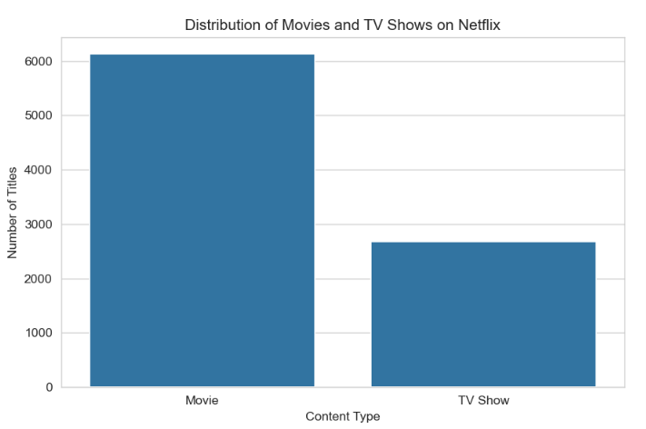
Interpretation
The visualization shows the distribution of Movies and TV Shows in the dataset.
The graph indicates which type of content is more common on Netflix within the dataset. If the Movie category has a substantially higher count, it indicates that movies form the larger portion of the available titles represented in the dataset.

12.2 Distribution of Release Years
The distribution of content according to release year was analyzed using a histogram.
plt.figure(figsize=(12,6))

plt.hist(df['release_year'], bins=30)

plt.title('Distribution of Netflix Titles by Release Year')
plt.xlabel('Release Year')
plt.ylabel('Number of Titles')

plt.show()

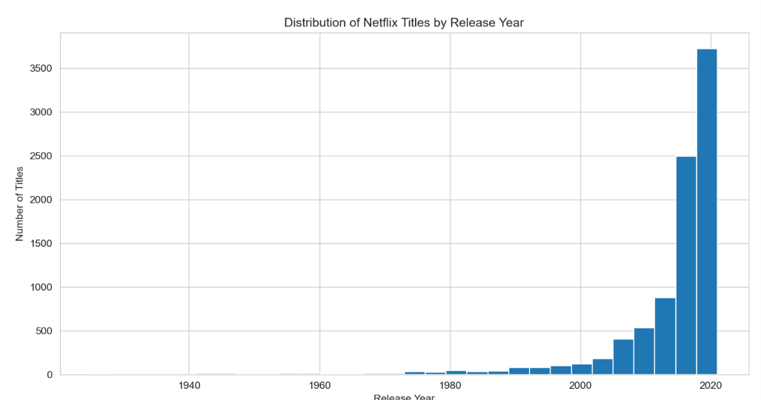
Interpretation
The histogram shows how Netflix titles are distributed across different release years.
A higher concentration of titles in recent years indicates that the dataset contains a large amount of relatively recent content. Older titles are present in smaller numbers compared with newer releases.

12.3 Top Content Ratings
The most common content ratings were analyzed using a count plot.

plt.figure(figsize=(10,6))

order = df['rating'].value_counts().head(10).index

sns.countplot(data=df, y='rating', order=order)

plt.title('Top 10 Content Ratings on Netflix')
plt.xlabel('Number of Titles')
plt.ylabel('Rating')

plt.show()

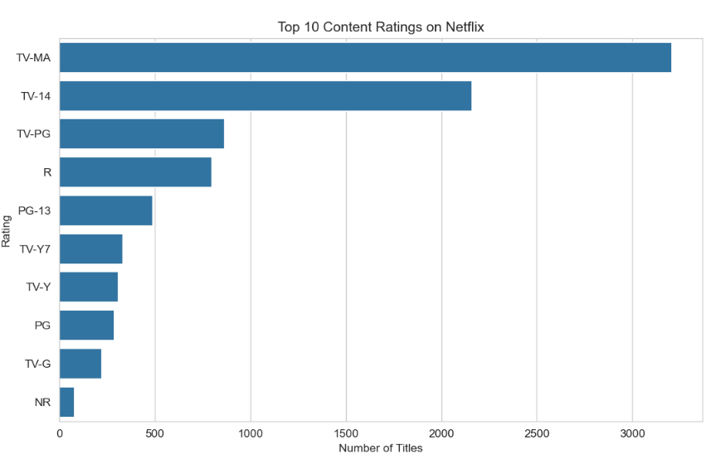

Interpretation
The graph displays the most frequently occurring content ratings.
The most common rating represents the category assigned to the largest number of titles in the dataset. The distribution of ratings provides an understanding of the types of content available on the platform.

12.4 Content Added to Netflix Over Time
The number of titles added to Netflix each year was calculated using grouping and aggregation.
yearly_additions = df['year_added'].value_counts().sort_index()

plt.figure(figsize=(12,6))

plt.plot(yearly_additions.index, yearly_additions.values, marker='o')

plt.title('Netflix Titles Added by Year')
plt.xlabel('Year Added')
plt.ylabel('Number of Titles')

plt.grid(True)

plt.show()

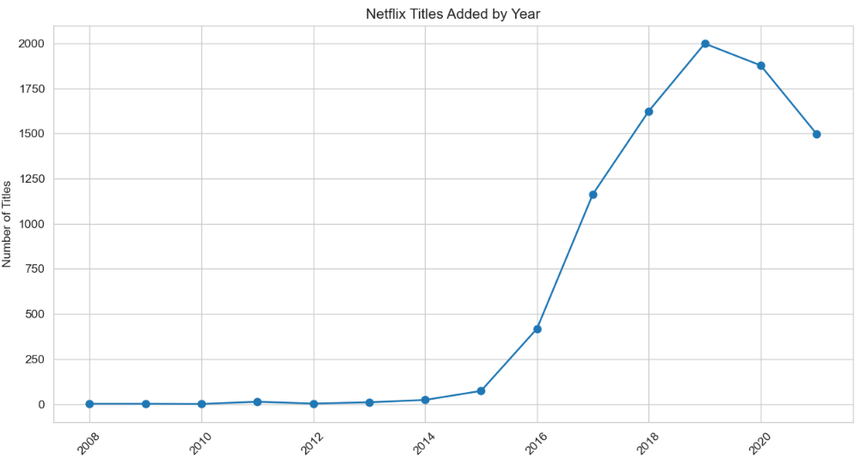
Interpretation
The line graph shows how the number of titles added to Netflix changed over the years.
An increasing trend suggests that Netflix expanded its content library during that period. A decrease in later years may also be influenced by differences in data collection or incomplete information for recent records.

12.5 Top Countries Producing Netflix Content
The country column was examined to identify countries associated with the largest number of titles.
Because some records contain multiple countries, the country values were separated before counting.
country_data = df['country'].str.split(', ').explode()

top_countries = country_data.value_counts().head(10)

plt.figure(figsize=(10,6))

sns.barplot(x=top_countries.values, y=top_countries.index)

plt.title('Top 10 Countries by Number of Netflix Titles')
plt.xlabel('Number of Titles')
plt.ylabel('Country')

plt.show()

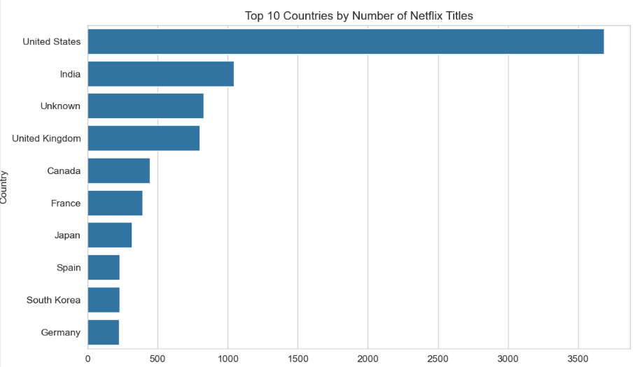
Interpretation
The visualization identifies the countries most frequently associated with Netflix titles.
Countries with higher values contribute a larger share of the content represented in the dataset. This demonstrates the international nature of Netflix's content library.

12.6 Most Common Content Categories
The listed_in column was analyzed to identify common genres and categories.

category_data = df['listed_in'].str.split(', ').explode()
top_categories = category_data.value_counts().head(10)

plt.figure(figsize=(10,6))

sns.barplot(x=top_categories.values, y=top_categories.index)

plt.title('Top 10 Netflix Content Categories')
plt.xlabel('Number of Titles')
plt.ylabel('Category')

plt.show()
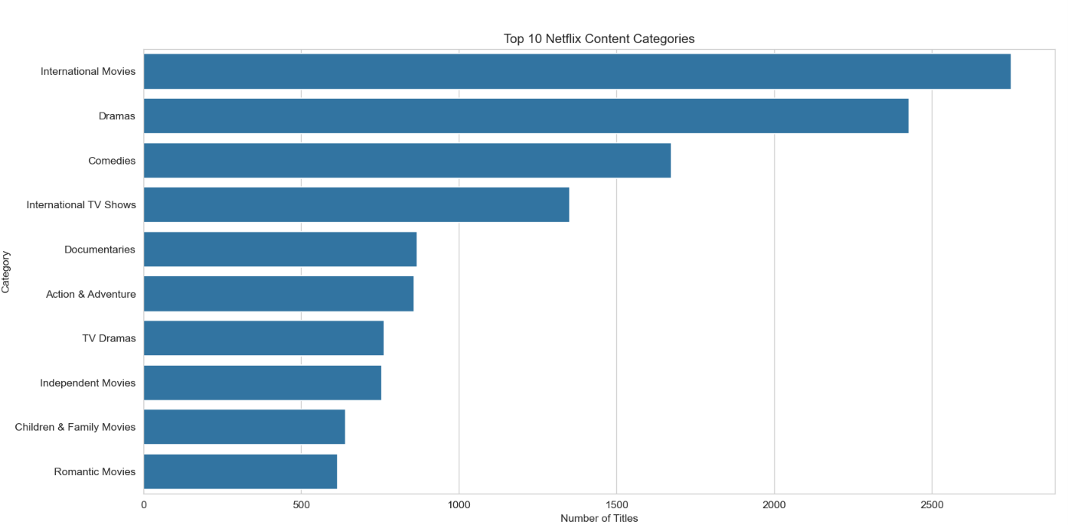

Interpretation
The bar chart displays the categories that occur most frequently in the dataset.
The most common categories indicate the types of content that are strongly represented in Netflix's catalog.

12.7 Relationship Between Content Type and Release Year
The relationship between content type and release year was examined.
plt.figure(figsize=(12,6))

sns.histplot(
data=df,
x='release_year',
hue='type',
bins=30,
multiple='stack'
)

plt.title('Movies and TV Shows by Release Year')
plt.xlabel('Release Year')
plt.ylabel('Number of Titles')

plt.show()

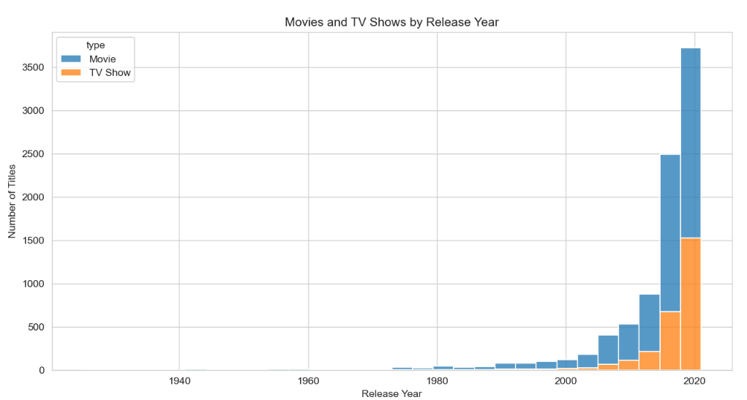
Interpretation
The visualization compares the distribution of Movies and TV Shows across release years.
It helps identify whether movies or TV shows dominate particular periods and shows how the composition of Netflix content has changed over time.

13. CORRELATION ANALYSIS
Correlation analysis was performed to examine the relationship between numerical variables.
The correlation matrix can be generated using:

numeric_df = df.select_dtypes(include=np.number)
correlation_matrix = numeric_df.corr()

plt.figure(figsize=(8,6))

sns.heatmap(
correlation_matrix,
annot=True,
cmap='coolwarm',
fmt='.2f'
)

plt.title('Correlation Heatmap')
plt.show()
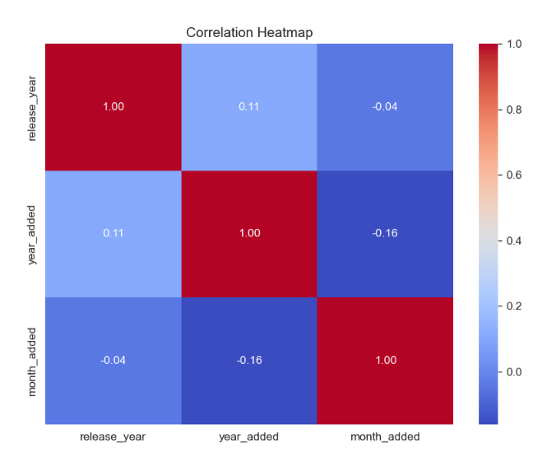

Interpretation
The correlation heatmap shows the strength and direction of relationships between numerical variables.
A correlation value close to +1 indicates a strong positive relationship, while a value close to -1 indicates a strong negative relationship. A value close to 0 indicates a weak or negligible linear relationship.
Correlation shows association between variables and does not by itself prove that one variable causes another.

14. KEY FINDINGS AND INSIGHTS
The major findings obtained from the exploratory analysis are summarized below:
- The dataset contains information about both Movies and TV Shows available on Netflix.
- Movies represent a larger portion of the dataset than TV Shows.
- The release-year analysis shows that a large proportion of the titles are from relatively recent years.
- The content-rating analysis shows that some ratings occur much more frequently than others.
- The yearly analysis demonstrates changes in the number of titles added to Netflix over time.
- The country analysis shows that Netflix content comes from many different countries, demonstrating the international nature of the platform.
- The category analysis identifies the genres and content types that occur most frequently.
- The comparison between Movies and TV Shows across release years helps identify differences in their distribution over time.
- Missing values were found in several columns and were handled appropriately based on the nature of the data.
- Correlation analysis was used to investigate relationships between numerical variables.

15. INTERPRETATION OF PATTERNS
The patterns identified during EDA can have several possible explanations.
The large representation of movies may be related to the historical size and composition of Netflix's content library.
The concentration of titles in recent release years may indicate Netflix's focus on newer content, although the distribution may also be influenced by the source dataset and the way records were collected.
The presence of content from many countries demonstrates Netflix's global reach and the diversity of its content library.
The variation in content ratings reflects the availability of programming intended for different audience groups.
Changes in the number of titles added over time may reflect Netflix's expansion, changes in content strategy, licensing agreements, or differences in the dataset's coverage.
These interpretations describe possible reasons for the observed patterns and should not automatically be treated as proof of causation.

16. LIMITATIONS OF THE ANALYSIS
Although the dataset provides useful information, the analysis has some limitations.
- Some columns contain missing values.
- Some titles are associated with multiple countries or multiple categories, making simple counting more complex.
- The dataset represents information available at the time it was collected and may not represent the current Netflix catalog.
- Correlation analysis only identifies statistical relationships and does not establish causation.
- Some variables contain text-based information that cannot be directly analyzed using standard numerical statistical methods.
- The dataset does not provide complete information about factors such as viewer ratings, viewing hours, popularity, or revenue.

17. CONCLUSION
This project demonstrated the process of performing Exploratory Data Analysis and Visualization using a public Netflix Movies and TV Shows dataset.
The analysis began with loading and inspecting the dataset, followed by checking data types, missing values, duplicates, and descriptive statistics. Data preprocessing and transformation were then performed to make the dataset more suitable for analysis.
Several visualizations were created using Matplotlib and Seaborn to explore the distribution of content types, release years, ratings, countries, categories, and yearly additions to Netflix.
The analysis revealed several meaningful patterns in the dataset, including the distribution of Movies and TV Shows, the concentration of titles across different release years, the most common ratings and categories, and the international distribution of Netflix content.
Overall, the project demonstrates how Exploratory Data Analysis can be used to transform a raw dataset into meaningful information through statistical analysis, visualization, and interpretation.

18. REFERENCES
- Netflix Movies and TV Shows public dataset.
- Python Documentation – Python programming language.
- Pandas Documentation – Data analysis and manipulation using Python.
- Matplotlib Documentation – Data visualization using Python.
- Seaborn Documentation – Statistical data visualization using Python.

APPENDIX: PYTHON CODE
The complete Python code used for loading, cleaning, analyzing, and visualizing the dataset is included in the accompanying Jupyter Notebook.
The notebook contains:
- Dataset loading
- Dataset inspection
- Missing-value analysis
- Duplicate detection
- Data cleaning
- Data transformation
- Descriptive statistics
- Grouping and aggregation
- Data visualization
- Correlation analysis
- Interpretation of results

